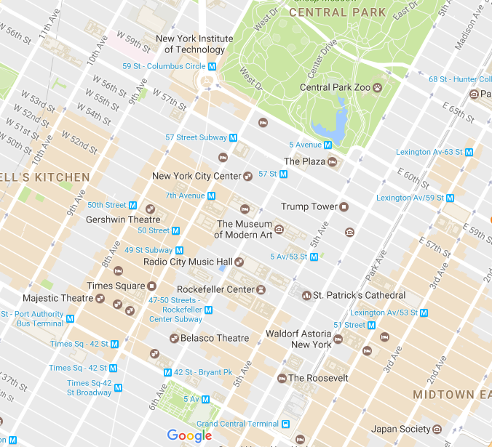

Brasserie 8 1/2

The Irish Pub

Fox & Friends (Newscorp)

Park Central Hotel

Carnegie Hall

Holiday Inn (Watson Hotel)