Driving Directions (PLEASE READ THESE INSTRUCTIONS BEFORE ATTEMPTING THIS TRIP!

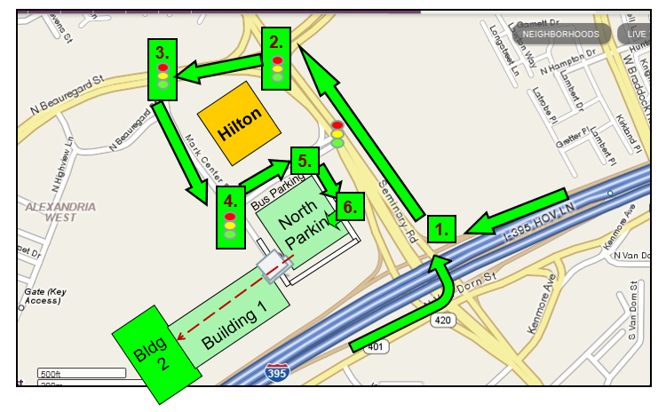
(Keep the Hilton Hotel on your left until MAP BOX 5)
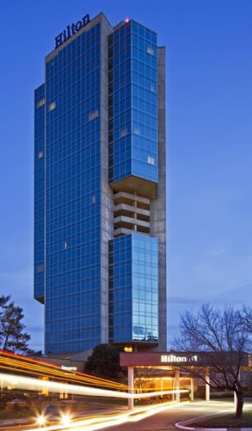

Take I-395

MAP BOX 1: At Exit 4, I-395, take ramp for Seminary Rd West.
MAP BOX 2: Turn Left (south) onto Beauregard Street.
MAP BOX 3: Next light, turn Left (east) onto Mark Center Drive.
MAP BOX 4: Next light, turn Left (north) proceed to MAP BOX 5. The North Parking Garage will be on your right
MAP BOX 5: Take the next right (south) at the building corner keeping the garage on your right
MAP BOX 6: Go to the SECOND ENTRANCE “Authorized Visitors.”
Turn right and enter and stop at the lifting pole/gate. Ring the intercom button, and speak into the intercom. Tell them your name.

Once you park, make note of where your vehicle is and what floor, as the interior of this garage is complex. At the south west corner of the North Parking is an elevator. Go upstairs to the Visitor’s Center (through a walkway over the street)

VISITOR CENTER INSTRUCTIONS (ALL VISITORS NOT JUST DRIVERS): At the window, you will be asked to provide a photo ID. You will be asked to enter your SSN on the keypad provided. Then you will be asked to enter your birthdate on the keypad. You will be asked to stand in front of the camera for a picture. Your visitor ID card for access will take a few minutes. You will be met by an escort at the Visitor’s Center to take you to the ceremony location.

