West Point Alumni Glee Club Rehearsals
Starting April 12, 2021, we will rehearse in the Choir Room that is in the lower level of the Sanctuary Building of St Agnes Catholic Church at 1910 N Randolph St, Arlington, VA, 22207. Map below:
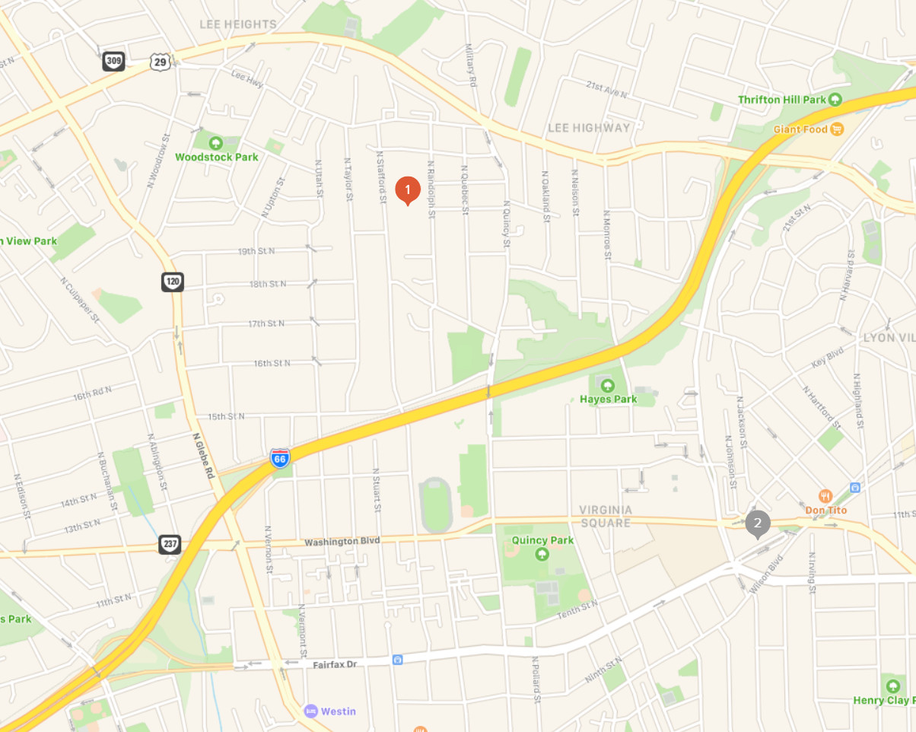
St Agnes
General Directions Driving: GPS directions may lead you to St Agnes off N Taylor St. While there is a church parking lot there, it is currently in use by the school. Use the parking lot off N. Randolph.
From the east (Washington DC):
Alternative 1: Exit I 66 West onto Lee Hwy going west. Where Quincy crosses Lee Hwy (also named Old Dominion Dr) Route 29, take Route 308 west about two blocks to N. Randolph. The church parking lot is one block south or the right hand side.
Alternative 2: Exit I 66 west onto N Glebe Road and turn right (north). At the next block turn right on 15th St North (it actually runs east-west). Go to the fifth intersection (counted by streets on your left) and turn left onto N.Randolph. After the next left hand turn, the church parking lot will be on your left.
From the west (I 495 and I 66)
Exit I 66 east at the Fairfax Drive exit. Turn left onto N. Glebe Road and cross over I 66. Turn left onto 15th St N (actually runs east and west). Go to the fifth intersection (counted by streets on your left) and turn left onto N.Randolph. After the next left hand turn, the church parking lot will be on your left.
On Campus Directions: Facing west in the parking lot you will see this building, the Sanctuary.
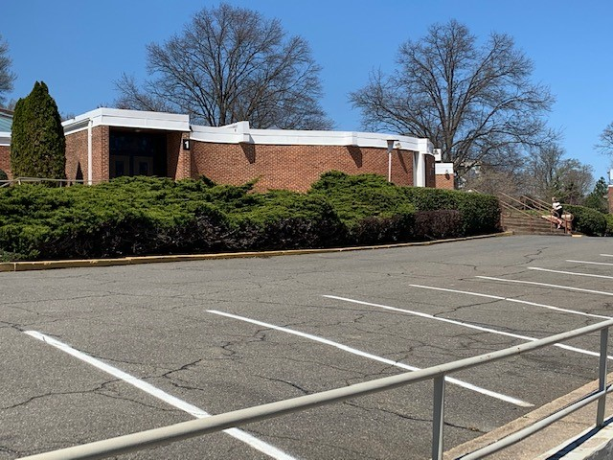
Note the black sign with a white 1 on it. Proceed to that entrance up a few steps shown here from that entrance.
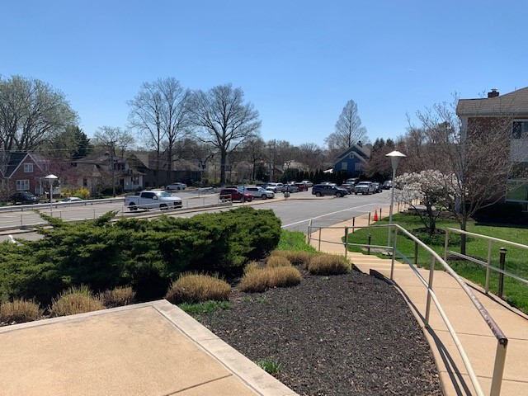
Once inside the entrance, immediately on the right-hand side is a set of stairs leading to the lower level. There is no elevator. Proceed to the choir room that opens to the right off the hallway. Rest rooms are also in that hallway.
